**[Integrating Amazon Alexa with Siebel CRM](https://github.com/orgs/opusgroupllc/teams/coa/discussions/4)**

Alexa is an intelligent (the artificial kind) personal assistant developed by Amazon. You can interact with Alexa via the echo or dot devices from Amazon or via an app. Alexa not only let's you buy (more smart internet-connected) things on the Amazon store but also answers questions and can control other things via 'skills'.

**Why integrate with Siebel (or other software)?**

Interacting with software such as Siebel CRM via an intelligent assistant might raise the question of "why?". But here are some use cases.

* The technology can help people with disabilities to use speech rather than haptic input.
* Enhanced mobility since you don't need to fondle your phone while driving.
* The assistant can act as a hub to other IoT devices.

**\*\* Alexa, create a Service Request!\*\***

A prototype which allows users to tell Alexa to create records in Siebel CRM.

For example, a Field Service Engineer encountering an issue could simply create a new Service Request by telling Alexa to do so.

[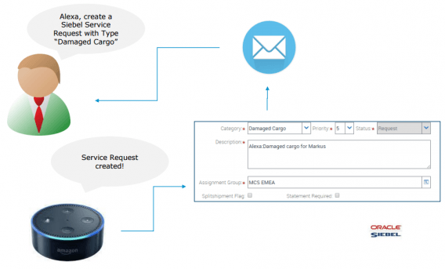](https://user-images.githubusercontent.com/54719627/64864041-3346c500-d604-11e9-8360-5081db83a547.png)

<https://www.siebelhub.com/main/2017/04/alexa-connect-to-siebel-please.html>